**JAVA LAB-REPORT**

**SUBMITTED BY:-**

**ANAGH.B.DESHPANDE**

**USN:-1BM22CS037**

**Practice programs:**

package java_code;

import java.util.*;

public class ex6{

public static void main(String[] args){

Scanner sc = new Scanner(System.in);

System.out.println("Anagh.B.Deshpande(1BM22CS037)");

System.out.println("enter no.");

int n1 = sc.nextInt();

int n2 = sc.nextInt();

sc.close();

System.out.println("prod: "+n1*n2);

}

}

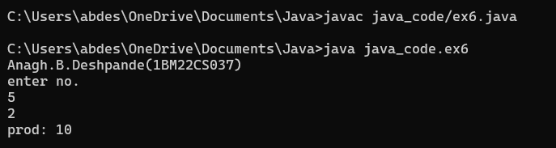

package java_code;

public class ex5 {

public static void main(String[] args) {

float n1 = 1.2f, n2 = 2.4f;

System.out.println("Anagh.B.Deshpande(1BM22CS037)");

System.out.println("1st no.: "+n1);

System.out.println("2nd no.: "+n2);

float tem = n1;

n1 = n2;

n2 = tem;

System.out.println("after swap:\n "+"1st no.: "+ n1 +"\n2nd no.: "+ n2);

}

}

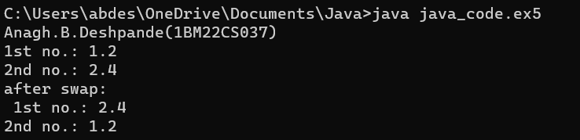

package java_code;

public class ex4 {

public static void main(String[] args) {

int n1 = 15, n2 = 2;

System.out.println("Anagh.B.Deshpande(1BM22CS037)");

System.out.println("number are 15 and 2");

System.out.println("quotient: "+ n1/n2);

System.out.println("remainder: "+ n1%n2);

}

}

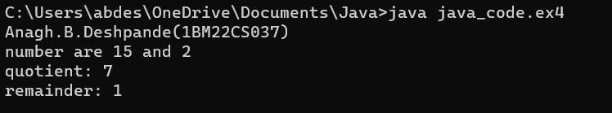

package java_code;

public class ex3 {

public static void main(String[] args) {

int row,col;

System.out.println("Anagh.B.Deshpande(1BM22CS037)");

for(row=0;row<8;row++)

{

for(col=0;col<=row;col++){

System.out.print("*");

}

System.out.println("");

}

}

}

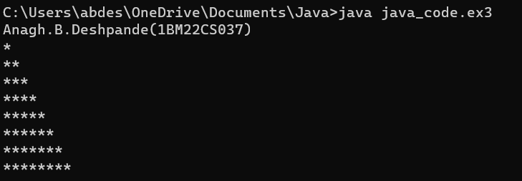

package java_code;

import java.util.Scanner;

public class ex2 {

public static void main(String[] args) {

Scanner sc = new Scanner(System.in);

System.out.println("Anagh.B.Deshpande(1BM22CS037)");

System.out.println("enter no.");

int num = sc.nextInt();

if (num%2==0){

System.out.println("even");

}

else {

System.out.println("odd");

}

}

}

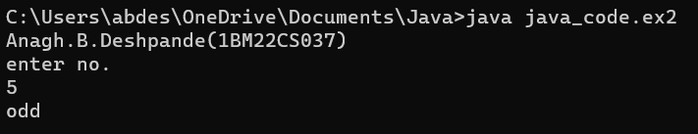

package java_code;

import java.util.*;

public class ex1{

public static void main(String[] args){

Scanner sc = new Scanner(System.in);

System.out.println("Anagh.B.Deshpande(1BM22CS037)");

System.out.println("enter no.");

int num = sc.nextInt();

System.out.println(num);

}

}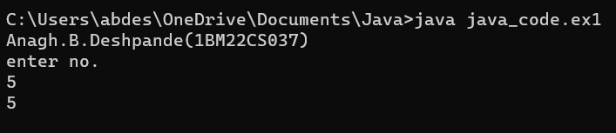

**Lab Program 1**  
Develop a Java program that prints all real solutions to the quadratic equation ax2+bx+c= 0.  
 Read in a, b, c and use the quadratic formula. If the discriminate b2-4ac is negative, display a message stating that there are no real solutions.

package java_code;

import java.util.Scanner;

import java.lang.Math;

public class Ad{

public static void main(String[] args){

float a,b,c,d;

Scanner ip = new Scanner(System.in);

System.out.println("Anagh.B.Deshpande(1BM22CS037)");

a = ip.nextFloat();b = ip.nextFloat();c = ip.nextFloat();

d = b*b-4*a*c;

if (d<0)

{System.out.println("Imaginary Roots");

System.out.println("R1 = " + (-b + Math.sqrt(d))/(2*a));

System.out.println("R2 = " + (-b - Math.sqrt(d))/(2*a));}

else if (d==0)

{System.out.println("Roots are Real and Equal");

System.out.println("R1 = R2 = " + -b/(2*a));}

else

{System.out.println("Roots are real and distinct");

System.out.println("R1 = " + (-b + Math.sqrt(d))/(2*a));

System.out.println("R2 = " + (-b - Math.sqrt(d))/(2*a));}

}

}

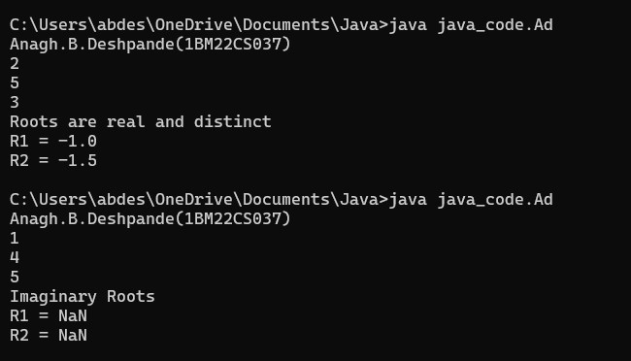

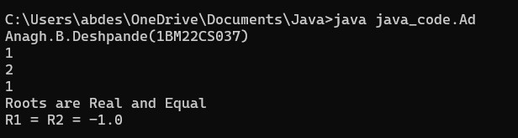

**Lab Program 2:**  
Develop a Java program to create a class Student with members usn, name, an array  
credits and an array marks. Include methods to accept and display details and a  
method to calculate SGPA of a student.

package java_code;

import java.util.Scanner;

class student{

String usn;

String name;

int credits[];

int marks[];

void accept(String usn,String name,int []credits,int []marks)

{

this.usn=usn;

this.name=name;

this.credits=credits;

this.marks=marks;

}

int calculate(int[] credits,int[] marks)

{

int sum1=0,sum2;

for(int i=0;i<8;i++)

{

sum1+=credits[i]*marks[i];

}

sum2=20;

System.out.println("1:"+sum1+"2:"+sum2);

return sum1/sum2;

}

void display(float sgpa)

{

System.out.println("usn:"+usn);

System.out.println("name:"+name);

System.out.println("sgpa:"+sgpa);

}

}

class addaedecedcwe{

public static void main(String[] args)

{

// char name,usn;

System.out.println("Anagh.B.Deshpande(1BM22CS037)");

Scanner sc = new Scanner(System.in);

System.out.println("enter size");

int size=sc.nextInt();

int[] marks = new int[size];

int[] credits = new int [size];

float res;

student s1=new student();

System.out.println("enter usn");

String usn = sc.next();

System.out.println("enter name");

String name=sc.next();

System.out.println("enter marks considering 91-100 as 10,81-90 as 9 and so on");

for(int i=0;i<size;i++)

{

marks[i]=sc.nextInt();

}

System.out.println("enter credits in sequential order");

for(int i=0;i<size;i++)

{

credits[i]=sc.nextInt();

}

s1.accept(usn,name,marks,credits);

res=s1.calculate(marks,credits);

s1.display(res);

}

}

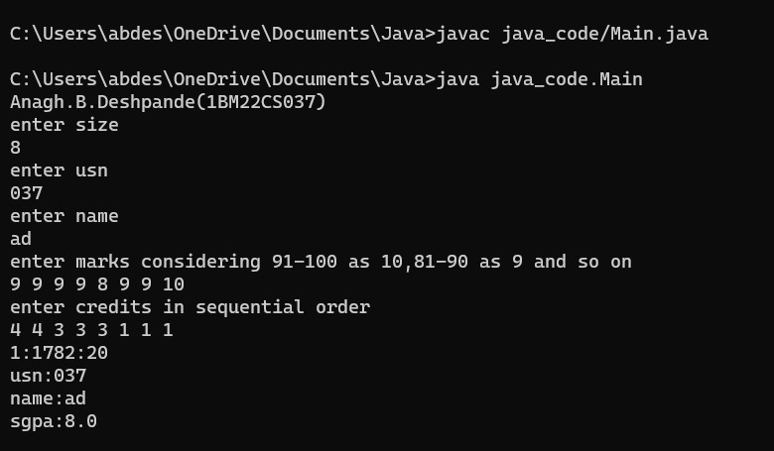

**Program 3:**  
Create a class Book which contains four members: name, author, price, num_pages.  
Include a constructor to set the values for the members. Include methods to set and  
get the details of the objects. Include a toString( ) method that could display the  
complete details of the book. Develop a Java program to create n book objects.

package java_code;

import java.util.Scanner;

class Books{

String name;

String author;

int price,i;

int num_pages;

public void set(int i){

Scanner in=new Scanner(System.in);

System.out.println("Enter details of books "+(i+1)+" in name,author,price,num_pages order");

name=in.next();

author=in.next();

price=in.nextInt();

num_pages=in.nextInt();

}

public String toString() {

return "Details of Book " + (i+1)+"\n"+

"Name: " + name + "\n" +

"Author: " + author + "\n" +

"Price: " + price + "\n" +

"No of pages: " + num_pages;

}

}

class D {

public static void main(String[] args) {

int n,i=0;

Scanner in=new Scanner(System.in);

System.out.println("Anagh.B.Deshpande(1BM22CS037)");

System.out.println("Enter number of books");

n=in.nextInt();

Books b[]=new Books[n];

for(i=0;i<n;i++){

b[i]=new Books();

b[i].set(i);

}

System.out.println();

for(i=0;i<n;i++){

System.out.println(b[i].toString());

}

}

}

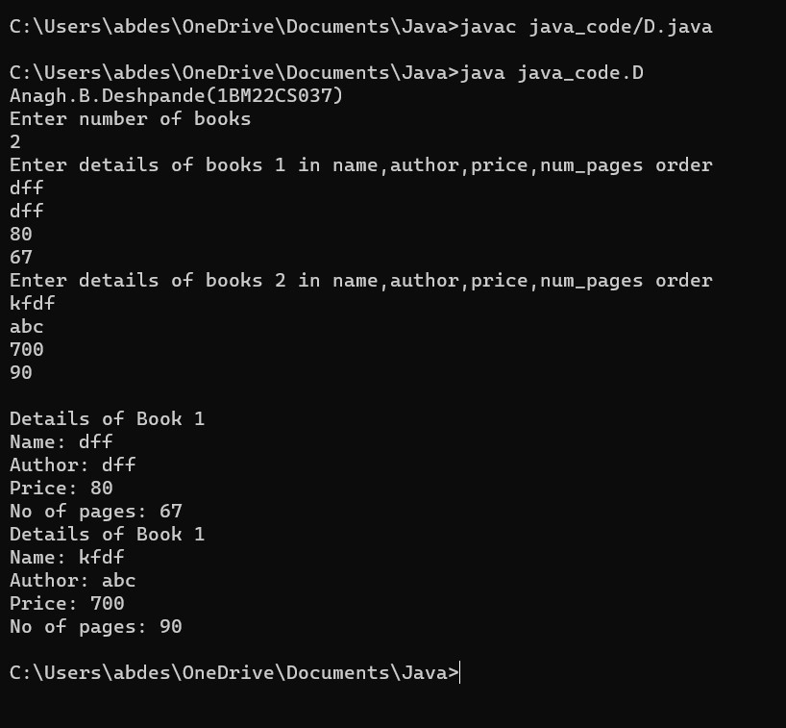

**Program 4:**  
Develop a Java program to create an abstract class named Shape that contains two  
integers and an empty method named printArea( ). Provide three classes named  
Rectangle, Triangle and Circle such that each one of the classes extends the class  
Shape. Each one of the classes contain only the method printArea( ) that prints the  
area of the given shape.

package java_code;

import java.util.Scanner;

abstract class Shape {

protected int side1;

protected int side2;

public Shape(int side1, int side2) {

this.side1 = side1;

this.side2 = side2;

}

public abstract void printArea();

}

class Rectangle extends Shape {

public Rectangle(int length, int width) {

super(length, width);

}

public void printArea() {

int area = side1 * side2;

System.out.println("Area of Rectangle: " + area);

}

}

class Triangle extends Shape {

public Triangle(int base, int height) {

super(base, height);

}

public void printArea() {

double area = 0.5 * side1 * side2;

System.out.println("Area of Triangle: " + area);

}

}

class Circle extends Shape {

public Circle(int radius) {

super(radius, radius);

}

public void printArea() {

double area = Math.PI * side1 * side1;

System.out.println("Area of Circle: " + area);

}

}

public class Main {

public static void main(String[] args) {

System.out.println("Anagh.B.Deshpande(1BM22CS037)");

Scanner scanner = new Scanner(System.in);

System.out.print("Enter length of Rectangle: ");

int length = scanner.nextInt();

System.out.print("Enter width of Rectangle: ");

int width = scanner.nextInt();

Rectangle rectangle = new Rectangle(length, width);

System.out.print("Enter base of Triangle: ");

int base = scanner.nextInt();

System.out.print("Enter height of Triangle: ");

int height = scanner.nextInt();

Triangle triangle = new Triangle(base, height);

System.out.print("Enter radius of Circle: ");

int radius = scanner.nextInt();

Circle circle = new Circle(radius);

scanner.close();

rectangle.printArea();

triangle.printArea();

circle.printArea();

}

}

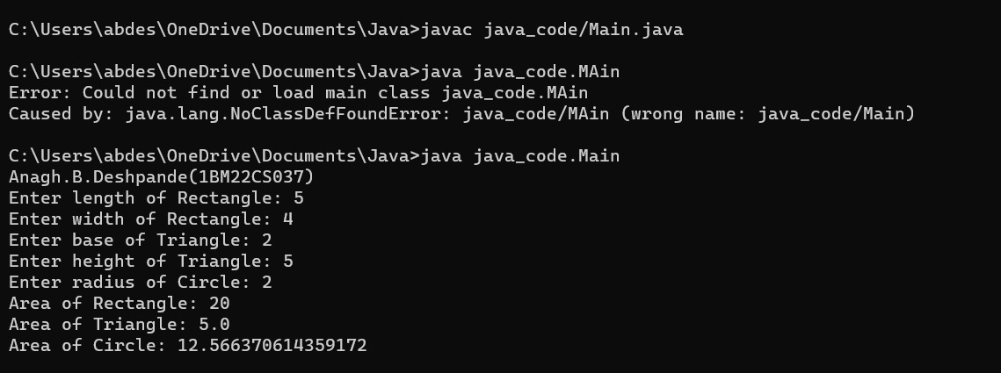

**Program:5**

Develop a Java program to create a class Bank that maintains two kinds of account for  
its customers, one called savings account and the other current account. The savings  
account provides compound interest and withdrawal facilities but no cheque book  
facility. The current account provides cheque book facility but no interest. Current  
account holders should also maintain a minimum balance and if the balance falls below  
this level, a service charge is imposed.  
Create a class Account that stores customer name, account number and type of  
account. From this derive the classes Cur-acct and Sav-acct to make them more specific  
to their requirements. Include the necessary methods in order to achieve the following  
tasks:  
a) Accept deposit from customer and update the balance.  
b) Display the balance.  
c) Compute and deposit interest  
d) Permit withdrawal and update the balance  
Check for the minimum balance, impose penalty if necessary and update the balance.

package java_code;

import java.util.Scanner;

class Account {

String customerName;

long accno;

String accountType;

double balance;

public Account(String customerName, long accno, String accountType) {

this.customerName = customerName;

this.accno = accno;

this.accountType = accountType;

this.balance = 0.0;

}

public void displayBalance() {

System.out.println("Account Number: " + accno);

System.out.println("Customer Name: " + customerName);

System.out.println("Account Type: " + accountType);

System.out.println("Balance: $" + balance);

}

}

class CurAcct extends Account {

double minBalance;

double serviceCharge;

public CurAcct(String customerName, long accno) {

super(customerName, accno, "Current");

this.minBalance = 500.0; // Set minimum balance

this.serviceCharge = 50.0; // Set service charge

}

public void withdraw(double amount) {

if (balance - amount >= minBalance) {

balance -= amount;

System.out.println("Withdrawal successful. Current Balance: $" + balance);

} else {

System.out.println("Insufficient funds. Withdrawal not allowed.");

}

}

public void imposeServiceCharge() {

if (balance < minBalance) {

balance -= serviceCharge;

System.out.println("Service charge imposed. Current Balance: Rs." + balance);

}

}

}

class SavAcct extends Account {

double interestRate;

public SavAcct(String customerName, long accno) {

super(customerName, accno, "Savings");

this.interestRate = 0.05;

}

public void depositInterest() {

double interest = balance * interestRate;

balance += interest;

System.out.println("Interest deposited. Current Balance: $" + balance);

}

public void compoundInterest(double initialAmount, int term) {

double compoundInterest = initialAmount * Math.pow((1 + interestRate), term) - initialAmount;

balance += compoundInterest;

System.out.println("Compound Interest deposited. Current Balance: Rs." + balance);

}

}

public class Bank {

public static void main(String[] args) {

System.out.println("Anagh.B.Deshpande(1BM22CS037)");

Scanner scanner = new Scanner(System.in);

System.out.println("Choose account type:");

System.out.println("1. Current");

System.out.println("2. Savings");

System.out.print("Enter choice (1 or 2): ");

int choice = scanner.nextInt();

System.out.print("Enter customer name: ");

String customerName = scanner.next();

System.out.print("Enter account number: ");

long accno = scanner.nextLong();

if (choice == 1) {

CurAcct curAccount = new CurAcct(customerName, accno);

System.out.print("Enter initial balance: $");

double initialBalance = scanner.nextDouble();

curAccount.balance = initialBalance;

System.out.print("Enter withdrawal amount: $");

double withdrawalAmount = scanner.nextDouble();

curAccount.withdraw(withdrawalAmount);

curAccount.imposeServiceCharge();

curAccount.displayBalance();

} else if (choice == 2) {

SavAcct savAccount = new SavAcct(customerName, accno);

System.out.print("Enter initial balance: $");

double initialBalance = scanner.nextDouble();

savAccount.balance = initialBalance;

System.out.print("Enter withdrawal amount: $");

double withdrawalAmount = scanner.nextDouble();

savAccount.balance -= withdrawalAmount;

System.out.println("Withdrawal successful. Current Balance: $" + savAccount.balance);

System.out.print("Enter interest rate: ");

double interestRate = scanner.nextDouble();

savAccount.interestRate = interestRate;

savAccount.displayBalance();

System.out.print("Enter term (in years) for compound interest calculation: ");

int term = scanner.nextInt();

savAccount.compoundInterest(initialBalance, term);

savAccount.displayBalance();

} else {

System.out.println("Invalid choice");

}

}

}

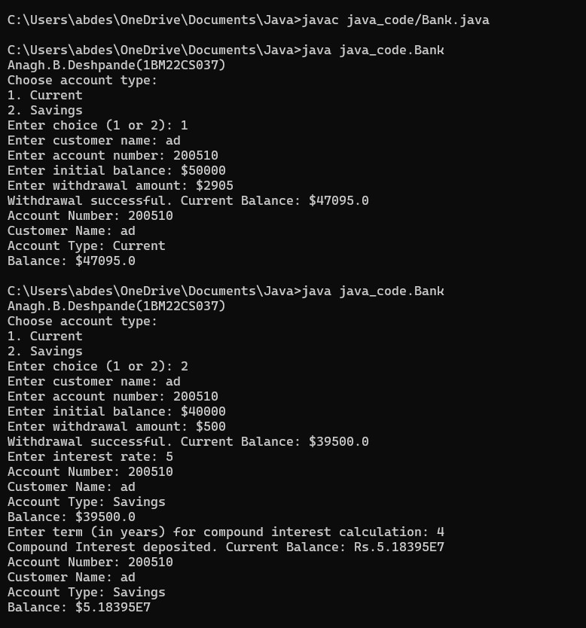

**Program:6**  
Create a package CIE which has two classes- Student and Internals. The class Personal  
has members like usn, name, sem. The class internals has an array that stores the  
internal marks scored in five courses of the current semester of the student. Create  
another package SEE which has the class External which is a derived class of Student.  
This class has an array that stores the SEE marks scored in five courses of the current  
semester of the student. Import the two packages in a file that declares the final marks  
of n students in all five courses.

package CIE;

public class Internals{

public int[] im = new int[5];

}

package CIE;

import java.util.*;

public class Student{

public String usn;

public String name;

public String sem;

public void accept(){

Scanner in = new Scanner(System.in);

usn = in.nextLine();

name = in.nextLine();

sem = in.nextLine();

}

}

package SEE;

import java.util.*;

import CIE.Student;

public class Externals extends Student{

public int[] sm = new int[5];

}

import java.util.*;

import CIE.*;

import SEE.*;

public class finalMarks

{

public static void main(String[] args)

{

Scanner ip = new Scanner(System.in);

System.out.println("Anagh.B.Deshpande(1BM22CS037)");

System.out.println("Enter no of students");

int[] fm = new int[5];

int n = ip.nextInt();

SEE.Externals st[] = new SEE.Externals[n];

CIE.Internals s[] = new CIE.Internals[n];

for(int i=0;i<n;i++)

{

st[i] = new SEE.Externals();

s[i] = new CIE.Internals();

System.out.println("Enter details usn,name,sem" + (i+1));

st[i].accept();

for(int j=0;j<5;j++)

{

System.out.println("Enter ima nd sm of sub" + (j+1));

s[i].im[j] = ip.nextInt();

st[i].sm[j] = ip.nextInt();

fm[j] = s[i].im[j] + st[i].sm[j];

}

System.out.println("Final marks "+st[i].name);

for(int k=0;k<5;k++)

{

System.out.println("Course "+(k+1)+"="+fm[k]);

}

}

}

}

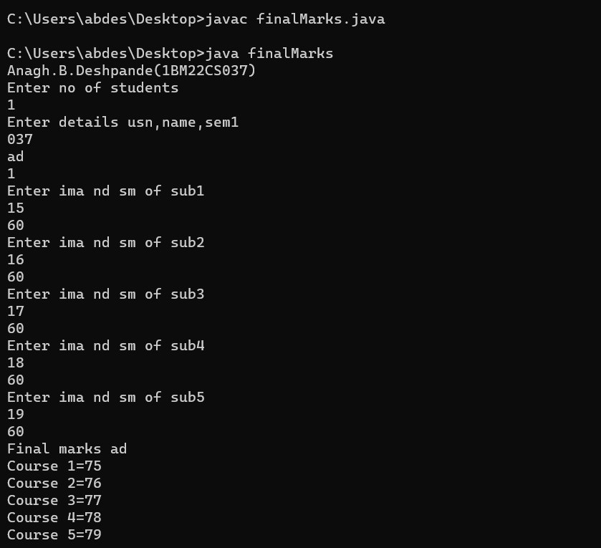

**Program 7:**  
Write a program that demonstrates handling of exceptions in inheritance tree. Create  
a base class called “Father” and derived class called “Son” which extends the base class.  
In Father class, implement a constructor which takes the age and throws the exception  
WrongAge( ) when the input age<0. In Son class, implement a constructor that cases  
both father and son’s age and throws an exception if son’s age is >=father’s age.

import java.util.Scanner;

class WrongAge extends Exception {

public WrongAge(String message) {

super(message);

}

}

class Father {

int fatherAge;

public Father(int fatherAge) throws WrongAge {

if (fatherAge < 0) {

throw new WrongAge("Age cannot be negative");

}

this.fatherAge = fatherAge;

}

}

class Son extends Father {

int sonAge;

public Son(int fatherAge, int sonAge) throws WrongAge {

super(fatherAge);

if (sonAge >= fatherAge) {

throw new WrongAge("Son's age must be less than Father's age");

}

this.sonAge = sonAge;

}

}

public class lab_7 {

public static void main(String[] args) {

Scanner sc = new Scanner(System.in);

System.out.println("Anagh.B.Deshpande(1BM22CS037)");

System.out.println("Enter father's age and son's age: ");

int fa=sc.nextInt();

int sa=sc.nextInt();

try {

Son s = new Son(fa, sa);

System.out.println("Father's age: " + s.fatherAge);

System.out.println("Son's age: " + s.sonAge);

} catch (WrongAge e) {

System.out.println("Error: " + e.getMessage());

}

}

}

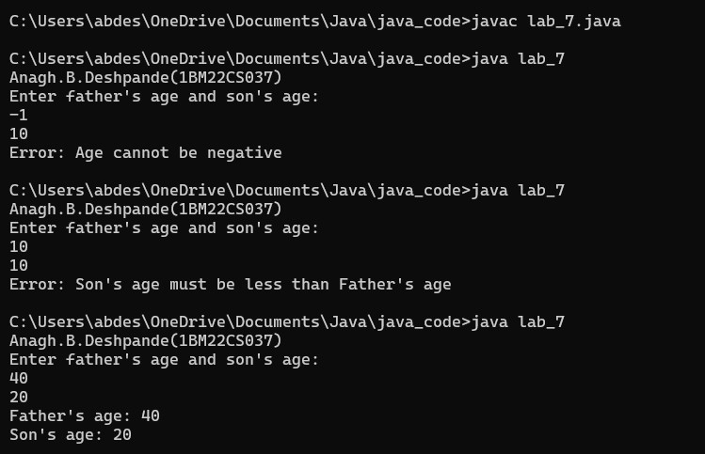

**Program 8:**  
Write a program which creates two threads, one thread displaying “BMS College of  
Engineering” once every ten seconds and another displaying “CSE” once every two  
seconds.

class A extends Thread{

A(){

}

public void run(){

while (true) {

System.out.println("BMSCE");

try {

sleep(10000);

} catch (Exception e) {

System.out.println("Error Occured in A");

}

}

}

}

class B extends Thread{

B(){

}

public void run(){

while (true) {

System.out.println("CSE");

try {

sleep(2000);

} catch (Exception e) {

System.out.println("Error Occured in B");

}

}

}

}

public class lab_8 {

public static void main(String[] args) {

System.out.println("Anagh.B.Deshpande(1BM22CS037)");

A a =new A();

B b = new B();

a.start();

b.start();

}

}

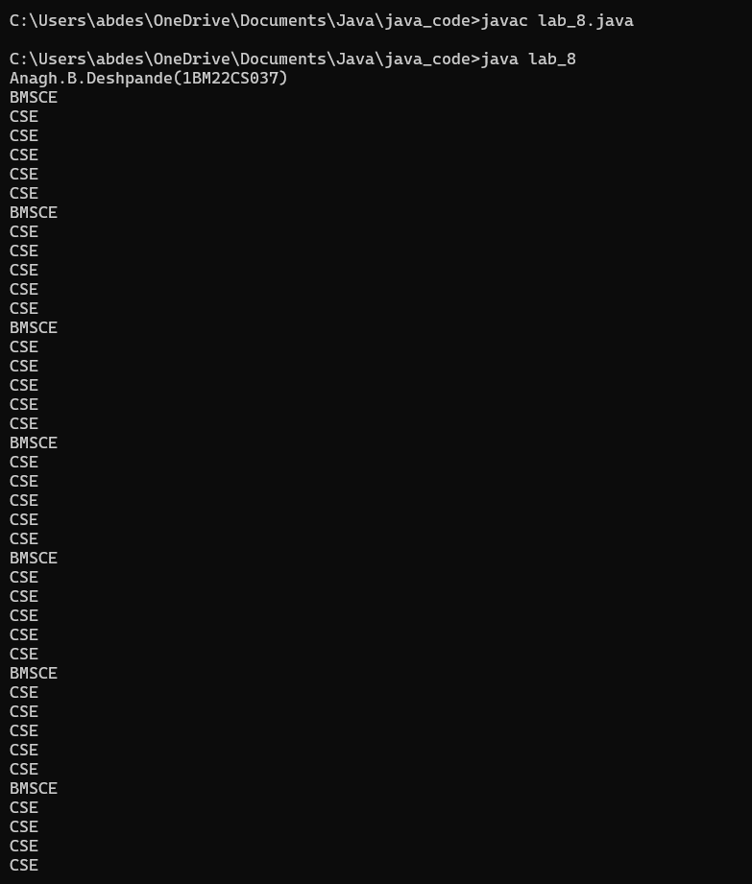

09) Write a program that creates a user interface to perform integer divisions. The user enters two numbers in the text fields, Num1 and Num2. The division of Num1 and Num2 is displayed in the Result field when the Divide button is clicked. If Num1 or Num2 were not an integer, the program would throw a NumberFormatException. If Num2 were Zero, the program would throw an Arithmetic Exception Display the exception in a message dialog box.

import javax.swing.*;

import java.awt.*;

import java.awt.event.*;

class SwingDemo{

    SwingDemo(){

        // create jframe container

        JFrame jfrm = new JFrame("Divider App");

        jfrm.setSize(275, 150);

        jfrm.setLayout(new FlowLayout());

        // to terminate on close

        jfrm.setDefaultCloseOperation(JFrame.EXIT_ON_CLOSE);

        // text label

        JLabel jlab = new JLabel("Enter the divider and divident:");

        // add text field for both numbers

        JTextField ajtf = new JTextField(8);

        JTextField bjtf = new JTextField(8);

        // calc button

        JButton button = new JButton("Calculate");

        // labels

        JLabel err = new JLabel();

        JLabel alab = new JLabel();

        JLabel blab = new JLabel();

        JLabel anslab = new JLabel();

        // add in order :)

        jfrm.add(err);  // to display error bois

        jfrm.add(jlab);

        jfrm.add(ajtf);

        jfrm.add(bjtf);

        jfrm.add(button);

        jfrm.add(alab);

        jfrm.add(blab);

        jfrm.add(anslab);

        ActionListener l = new ActionListener() {

            public void actionPerformed(ActionEvent evt) {

                System.out.println("Action event from a text field");

            }

        };

        ajtf.addActionListener(l);

        bjtf.addActionListener(l);

        button.addActionListener(new ActionListener() {

            public void actionPerformed(ActionEvent evt) {

                try{

                    int a = Integer.parseInt(ajtf.getText());

                    int b = Integer.parseInt(bjtf.getText());

                    int ans = a/b;

                    alab.setText("\nA = " + a);

                    blab.setText("\nB = " + b);

                    anslab.setText("\nAns = "+ ans);

                }

                catch(NumberFormatException e){

                    alab.setText("");

                    blab.setText("");

                    anslab.setText("");

                    err.setText("Enter Only Integers!");

                }

                catch(ArithmeticException e){

                    alab.setText("");

                    blab.setText("");

                    anslab.setText("");

                    err.setText("B should be NON zero!");

                }

            }

        });

        // display frame

        jfrm.setVisible(true);

    }

    public static void main(String args[]){

        // create frame on event dispatching thread

        SwingUtilities.invokeLater(new Runnable(){

            public void run(){

                new SwingDemo();

            }

        });

    }

}

